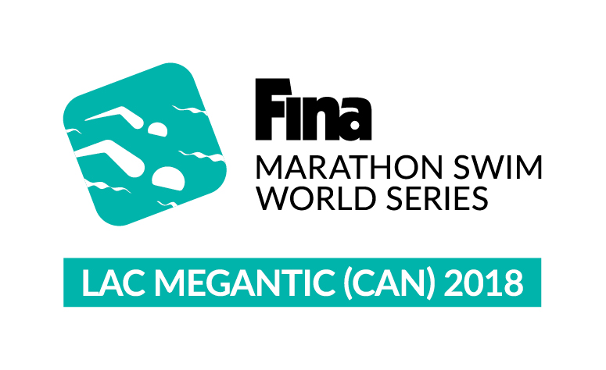 | INFORMATION BULLETIN  FINA-HOSA 10KM MARATHON SWIMMING WORLD CUP  Saturday, August 11th, 2018 – Lac-Mégantic (CAN) | 

1. VENUE
1.1 - The 10 kilometers swimming marathon is organized by LA TRAVERSÉE INTERNATIONALE DU LAC MÉGANTIC.
1.2 - The marathon, open to men and women, will take place on August 11th, 2018 over a distance of 10 km in Lac-Mégantic.
1.3 - The marathon will start at one (1) o’clock pm, at Piopolis’ municipal beach.
1.4 - Each swimmer must be accompanied by a qualified coach.

2. CONFIRMATION
2.1 - The document confirming participation of the swimmer after receiving his (her) acceptation from the organizing committee must be received by fax and/or writing by the office of the Organizing Committee before July 2nd, 2018.

3. SWIMMERS' AND COACHES' ARRIVAL/DEPARTURE
3.1 - The swimmer and the coach must reach the office of the Organizing Committee at their own expense no later than Thursday August 9th, 2018 at noon. They must inform the Organizing Committee of their arrival.

3.2 - The swimmer and the coach must not leave Lac-Mégantic and the area before Sunday August 12th, 2018 at (11:00) o'clock am without the authorization of the Organizing Committee.

4. BURSARIES
4.1 - The purses will be distributed to the swimmers based on their rank at their arrival. If the total of the distributed purses available for distribution is not all distributed, the difference between the amount given and the total of the available money for distribution will be equally distributed among the swimmers who will have completed the course and will have touched the finish wall. The purses will be paid in US currency.

4.2 - Revenue Canada requires that a 15% tax be perceived, by la Traversée, on purses of $2,500 CND and over on the total amount of money awarded to each non Canadian residents. The swimmer can file a claim to Revenue Canada in order to recover, if applicable, a partial or total refund, based on certain conditions and/or arrangements between Canada and his own country. It is advisable to keep receipts for all expenses related to the marathon.

TOTAL : $30,000 US
WOMEN |  | MEN
1st | $ 4,000 | 1st | $ 4,000
2nd | $ 3,000 | 2nd | $ 3,000
3rd | $ 2,300 | 3rd | $ 2,300
4th | $ 1,700 | 4th | $ 1,700
5th | $ 1,300 | 5th | $ 1,300
6th | $ 1,100 | 6th | $ 1,100
7th | $ 900 | 7th | $ 900
8th | $ 700 | 8th | $ 700

5. ACCOMMODATION
5.1 - As the Rules and Regulations of the 10 km Marathon Swimming World Cup 2011, will take responsibility of accommodation for the swimmer and the coach, from Tuesday, August 7th to Sunday August 13th, 2016 inclusively, i.e. in hotel or the Organizing Committee can use another way to accommodate the swimmer and his coach. All other accompanying people will be responsible for their transportation and lodging expenses. The swimmer has the obligation to confirm the identity of his coach for this one to be lodge, at the August 5st, 2016.

6. PARTICIPATION
6.1 - The swimmer must accept unconditionally to participate in all activities regarding the swimmers (including: interviews with media, fund raising evening, swimmers’ presentation, presentation of awards, parades, etc.).

7. MEETINGS
7.1 - The coaches must be present at all meetings scheduled by the organizing committee. Technical meeting: Friday, August 10th at 10:30 am.

8. ENDING OF THE MARATHON AND CANCELLATION
8.1 - If the marathon is cancelled, the Organizing Committee will assume the cost non‐refundable including the flight, the lodging and the subscribing fees that must be paid by the swimmer already registered in the marathon on presentation of supporting documents. Refunding will vary according to the number of marathon where the swimmer is registered in North America.

9. REGULATIONS
9.1 - Any infringement of the present contract or Rules of Competition may result in a fine and/or disqualification which will be decided by the Organizing Committee. Each fine will be a minimum of $150 US for each breach of a clause and/or rules and/or absence from any scheduled event. More severe fines may be applied depending upon the gravity of the offense. The fine may be deducted from the bursaries or sought in any other legal manner.
9.2 - The organizing committee will not accept destructive and disrespectful attitudes towards the organization. Athletes must refrain from publicly criticizing the welcoming organization; however, the organizing committee remains open to receive any comment on an individual basis. Any behavior opposed to sportsmanlike ethics will be penalized financially and/or otherwise, and could lead to the interdiction to participate.

Contact info: Alexandra Désilets, Race Director, Email: Traversee@lacenfetemegantic.com
Title Sponsor

